MEDIUM: Potentially Unsafe Code - Code Appears to Contain Hard-Coded Password
Line: 1863 - C:\_data\Intranet_swz-appbuilder-clover.08042019\swz-appbuilder-clover\swz.Clover.Application\BusinessProcess.cs
The code may contain a hard-coded password which an attacker could obtain from the source or by dis-assembling the executable. Please manually review the code:
OwnerPassword = "ownerpassQkQVcKqsMCDu#nv+"

FIX: remove password. No pdf password is needed for data editor

STANDARD: Potentially Unsafe Code - Integer Operation Without Overflow Check
Line: 1943 - C:\_data\Intranet_swz-appbuilder-clover.08042019\swz-appbuilder-clover\swz.Clover.Application\BusinessProcess.cs
The code carries out integer operations without enabling overflow defences. Manually review the code to ensure that it is safe
for (int i = 0; i < dyMsgSampleObjectsList.Count; i = i + 500)

STANDARD: Potentially Unsafe Code - Integer Operation Without Overflow Check
Line: 2300 - C:\_data\Intranet_swz-appbuilder-clover.08042019\swz-appbuilder-clover\swz.Clover.Application\BusinessProcess.cs
The code carries out integer operations without enabling overflow defences. Manually review the code to ensure that it is safe
for (int j = 0; j < dyMsgSampleObjectsList.Count; j = j + 500)

STANDARD: Potentially Unsafe Code - Integer Operation Without Overflow Check
Line: 2605 - C:\_data\Intranet_swz-appbuilder-clover.08042019\swz-appbuilder-clover\swz.Clover.Application\BusinessProcess.cs
The code carries out integer operations without enabling overflow defences. Manually review the code to ensure that it is safe
for (int i = 0; i < arrRecipients.Length; i++)

STANDARD: Potentially Unsafe Code - Integer Operation Without Overflow Check
Line: 2709 - C:\_data\Intranet_swz-appbuilder-clover.08042019\swz-appbuilder-clover\swz.Clover.Application\BusinessProcess.cs
The code carries out integer operations without enabling overflow defences. Manually review the code to ensure that it is safe
for (int i = 0; i < arrRecipients.Length; i++)

FIX: Add integer overflow check in the project level:

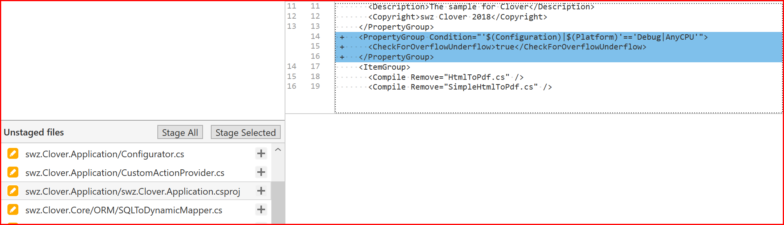

This will do the overflow check for all above loops. Please refer to: https://docs.microsoft.com/en-us/visualstudio/code-quality/ca2233?view=vs-2019, where it is mentioned:

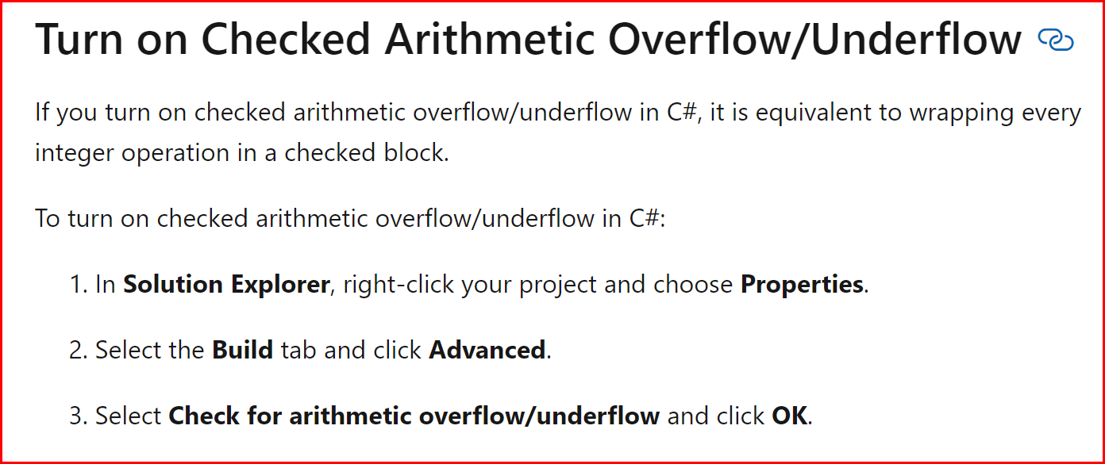

Please know that code scan will still flag the above items due to its limitation.

MEDIUM: Potentially Unsafe Code - Thread Locks - Possible Performance Impact
Line: 3107 - C:\_data\Intranet_swz-appbuilder-clover.08042019\swz-appbuilder-clover\swz.Clover.Application\BusinessProcess.cs
There are 60 lines of code in the locked code block. Manually check the code to ensure any shared resources are not being locked unnecessarily.

Note: The lock is deliberately introduced to allow only one thread to perform expensive operations

SUSPICIOUS COMMENT: Comment Indicates Potentially Unfinished Code -
Line: 52 - C:\_data\Intranet_swz-appbuilder-clover.08042019\swz-appbuilder-clover\swz.Clover.Application\Configurator.cs
TODO add write to log

FIX: write mentioned exceptions to log

SUSPICIOUS COMMENT: Comment Indicates Potentially Unfinished Code -
Line: 510 - C:\_data\Intranet_swz-appbuilder-clover.08042019\swz-appbuilder-clover\swz.Clover.Application\CustomActionProvider.cs
TODO encrypt userpass

FIX: remove it as the userpass is generated dynamically in the stored procedure

SUSPICIOUS COMMENT: Comment Indicates Potentially Unfinished Code -
Line: 52 - C:\_data\Intranet_swz-appbuilder-clover.08042019\swz-appbuilder-clover\swz.Clover.Application\WorkflowInit.cs
TODO If you have planned to use Code Actions functionality that required references to external assemblies you have to register them here

SUSPICIOUS COMMENT: Comment Indicates Potentially Unfinished Code -
Line: 55 - C:\_data\Intranet_swz-appbuilder-clover.08042019\swz-appbuilder-clover\swz.Clover.Application\WorkflowInit.cs
TODO If you have planned use Timers the best way to start WorkflowRuntime is somwhere outside of this function in Global.asax for example

SUSPICIOUS COMMENT: Comment Indicates Potentially Unfinished Code -
Line: 66 - C:\_data\Intranet_swz-appbuilder-clover.08042019\swz-appbuilder-clover\swz.Clover.Application\WorkflowInit.cs
TODO change Document transition history and WorkflowInbox

FIX: remove WorkflowInit.cs as it is not used for SIMS

